
Lab no: 4 Date: 2082/05/15

Title: Write a program to calculate the average turnaround time and waiting time for user input process parameters using FCFS process scheduling algorithm.

Introduction
The First Come First Serve (FCFS) scheduling algorithm is one of the simplest and most fundamental CPU scheduling techniques used in operating systems. In this method, processes are executed in the order in which they arrive in the ready queue, much like customers waiting in line at a ticket counter. The process that arrives first is executed first, and once a process starts execution, it runs until completion without being interrupted, making FCFS a non-preemptive scheduling algorithm.
In FCFS, the CPU acts like a queue where processes wait for their turn. Each process has certain parameters: Arrival Time (AT), which is when the process enters the ready queue; Burst Time (BT), which is the amount of CPU time required by the process; Completion Time (CT), when the process finishes execution; Turnaround Time (TAT), which is the total time taken from arrival to completion; and Waiting Time (WT), which is the time a process spends waiting in the ready queue before execution. These values help in evaluating the performance of the scheduling algorithm.
The Turnaround Time (TAT) is calculated using the formula:
TAT=CT−ATTAT = CT - ATTAT=CT−AT
The Waiting Time (WT) is calculated using the formula:
WT=TAT−BTWT = TAT - BTWT=TAT−BT
FCFS scheduling is fair because every process gets CPU time in the order of its arrival, and it is also very easy to implement. However, one major drawback of FCFS is the convoy effect, where shorter processes may have to wait for a long time if a longer process arrives first.

IDE: DEV C++
Source code:

#include <iostream>
#include <vector>
#include <algorithm>
#include <iomanip>
using namespace std;

struct Process {
int pid; // Process ID
int at; // Arrival Time
int bt; // Burst Time
int ct; // Completion Time
int tat; // Turnaround Time
int wt; // Waiting Time
};

// Comparator for stable_sort (keeps input order when AT ties)
bool cmpByAT(const Process& a, const Process& b) {
return a.at < b.at;
}

int main() {
int n;
cout << "Enter number of processes: ";
if (!(cin >> n) || n <= 0) {
cout << "Invalid number of processes.\n";
return 0;
}

vector<Process> p(n);
for (int i = 0; i < n; i++) {
p[i].pid = i + 1;
cout << "Enter Arrival Time of P" << i + 1 << ": ";
cin >> p[i].at;
cout << "Enter Burst Time of P" << i + 1 << ": ";
cin >> p[i].bt;
p[i].ct = p[i].tat = p[i].wt = 0;
}

// Sort by arrival time; stable_sort preserves input order on ties
stable_sort(p.begin(), p.end(), cmpByAT);

int time = 0;
for (int i = 0; i < n; i++) {
if (time < p[i].at) {
time = p[i].at; // CPU idle until next process arrives
}
time += p[i].bt;
p[i].ct = time;
p[i].tat = p[i].ct - p[i].at;
p[i].wt = p[i].tat - p[i].bt;
}

double avg_tat = 0.0, avg_wt = 0.0;

cout << "\nProcess\tAT\tBT\tTAT\tWT\n";
for (int i = 0; i < n; i++) {
cout << "P" << p[i].pid << "\t"
<< p[i].at << "\t"
<< p[i].bt << "\t"
<< p[i].tat << "\t"
<< p[i].wt << "\n";
avg_tat += p[i].tat;
avg_wt += p[i].wt;
}

cout << fixed << setprecision(2);
cout << "\nAverage Turnaround Time = " << (avg_tat / n);
cout << "\nAverage Waiting Time = " << (avg_wt / n) << endl;

return 0;
}

Output:

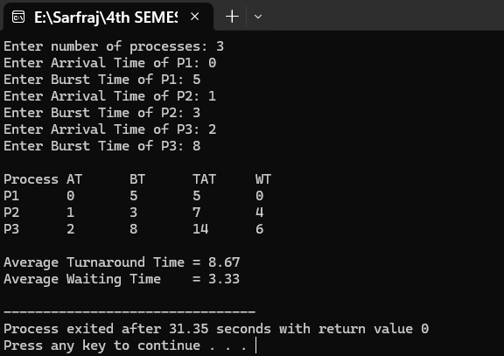

Lab no: 5 Date: 2082/05/14

Title:Write a program to calculate the average turnaround time and waiting time for user input process parameters using SJF process scheduling algorithm.

Introduction
The Shortest Job First (SJF) scheduling algorithm is one of the most efficient CPU scheduling techniques used in operating systems. In this method, the process with the smallest burst time is executed first. If two processes have the same burst time, they are scheduled according to their order of arrival. SJF can be of two types: Non-Preemptive SJF, where once a process starts execution it runs until completion, and Preemptive SJF (Shortest Remaining Time First - SRTF), where a newly arrived process with a shorter burst time can preempt the currently running process.
In SJF, the CPU gives priority to processes that require less execution time, which minimizes the average waiting time and average turnaround time compared to FCFS. Each process has the same set of parameters as in other scheduling algorithms: Arrival Time (AT), Burst Time (BT), Completion Time (CT), Turnaround Time (TAT), and Waiting Time (WT).
The Turnaround Time (TAT) is calculated as:
TAT=CT−ATTAT = CT - ATTAT=CT−AT
The Waiting Time (WT) is calculated as:
WT=TAT−BTWT = TAT - BTWT=TAT−BT
SJF is considered the optimal scheduling algorithm for minimizing average waiting time. However, its major drawback is that it requires knowledge of the CPU burst time in advance, which is not always possible. Moreover, in the non-preemptive version, a longer process may block shorter ones that arrive later, and in the preemptive version, frequent context switching may occur.

IDE: DEV C++
Source code:

#include <iostream>
#include <vector>
#include <algorithm>
#include <iomanip>
using namespace std;

struct Process {
int pid; // Process ID
int at; // Arrival Time
int bt; // Burst Time
int ct; // Completion Time
int tat; // Turnaround Time
int wt; // Waiting Time
bool done; // Flag to mark completion
};

int main() {
int n;
cout << "Enter number of processes: ";
cin >> n;

vector<Process> p(n);
for (int i = 0; i < n; i++) {
p[i].pid = i + 1;
cout << "Enter Arrival Time of P" << i + 1 << ": ";
cin >> p[i].at;
cout << "Enter Burst Time of P" << i + 1 << ": ";
cin >> p[i].bt;
p[i].ct = p[i].tat = p[i].wt = 0;
p[i].done = false;
}

int completed = 0, time = 0;
while (completed < n) {
int idx = -1;
int minBT = 1e9;

// Select process with shortest burst time among arrived & not done
for (int i = 0; i < n; i++) {
if (!p[i].done && p[i].at <= time) {
if (p[i].bt < minBT) {
minBT = p[i].bt;
idx = i;
} else if (p[i].bt == minBT) {
// Tie-breaking by arrival time
if (p[i].at < p[idx].at) idx = i;
}
}
}

if (idx == -1) {
time++; // CPU idle
} else {
time += p[idx].bt;
p[idx].ct = time;
p[idx].tat = p[idx].ct - p[idx].at;
p[idx].wt = p[idx].tat - p[idx].bt;
p[idx].done = true;
completed++;
}
}

double avg_tat = 0.0, avg_wt = 0.0;

cout << "\nProcess\tAT\tBT\tTAT\tWT\n";
for (int i = 0; i < n; i++) {
cout << "P" << p[i].pid << "\t"
<< p[i].at << "\t"
<< p[i].bt << "\t"
<< p[i].tat << "\t"
<< p[i].wt << "\n";
avg_tat += p[i].tat;
avg_wt += p[i].wt;
}

cout << fixed << setprecision(2);
cout << "\nAverage Turnaround Time = " << (avg_tat / n);
cout << "\nAverage Waiting Time = " << (avg_wt / n) << endl;

return 0;
}

Output:
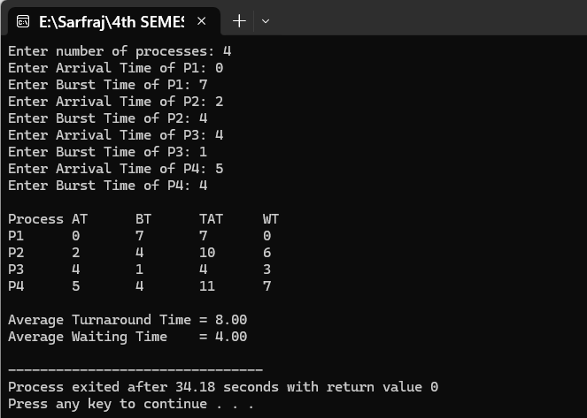

Lab no: 6 Date: 2082/05/14

Title:Write a program to calculate the average turnaround time and waiting time for user input process parameters using RR process scheduling algorithm.

Introduction

The Round Robin (RR) scheduling algorithm is one of the most widely used preemptive CPU scheduling techniques in operating systems. In this method, each process is assigned a fixed time slice or time quantum, and the CPU executes each process for that duration in a cyclic order. If a process does not finish within its time quantum, it is preempted and placed at the back of the ready queue, and the CPU is given to the next process. This continues until all processes are completed.
Round Robin scheduling is designed especially for time-sharing systems, as it ensures that no single process monopolizes the CPU and that all processes get an equal share of CPU time. Each process has the same set of parameters as in other scheduling algorithms: Arrival Time (AT), Burst Time (BT), Completion Time (CT), Turnaround Time (TAT), and Waiting Time (WT).
The Turnaround Time (TAT) is calculated as:
TAT=CT−ATTAT = CT - ATTAT=CT−AT
The Waiting Time (WT) is calculated as:
WT=TAT−BTWT = TAT - BTWT=TAT−BT
Round Robin is considered a fair scheduling algorithm because each process gets an equal opportunity to run. Its performance heavily depends on the choice of the time quantum. If the time quantum is too large, RR behaves like FCFS. If the time quantum is too small, too much context switching occurs, which reduces CPU efficiency.

IDE: DEV C++
Source code:
#include <iostream>
#include <vector>
#include <queue>
#include <iomanip>
using namespace std;

struct Process {
int pid; // Process ID
int at; // Arrival Time
int bt; // Burst Time
int rt; // Remaining Time
int ct; // Completion Time
int tat; // Turnaround Time
int wt; // Waiting Time
};

int main() {
int n, tq;
cout << "Enter number of processes: ";
cin >> n;

vector<Process> p(n);
for (int i = 0; i < n; i++) {
p[i].pid = i + 1;
cout << "Enter Arrival Time of P" << i + 1 << ": ";
cin >> p[i].at;
cout << "Enter Burst Time of P" << i + 1 << ": ";
cin >> p[i].bt;
p[i].rt = p[i].bt; // initially remaining time = burst time
p[i].ct = p[i].tat = p[i].wt = 0;
}

cout << "Enter Time Quantum: ";
cin >> tq;

queue<int> q; // stores process indices
int time = 0, completed = 0;
vector<bool> inQueue(n, false);

// Initially push processes that arrive at time 0
for (int i = 0; i < n; i++) {
if (p[i].at == 0) {
q.push(i);
inQueue[i] = true;
}
}

while (completed < n) {
if (q.empty()) {
time++; // CPU idle
for (int i = 0; i < n; i++) {
if (!inQueue[i] && p[i].at <= time) {
q.push(i);
inQueue[i] = true;
}
}
continue;
}

int idx = q.front();
q.pop();

if (p[idx].rt > tq) {
time += tq;
p[idx].rt -= tq;
} else {
time += p[idx].rt;
p[idx].rt = 0;
p[idx].ct = time;
p[idx].tat = p[idx].ct - p[idx].at;
p[idx].wt = p[idx].tat - p[idx].bt;
completed++;
}

// Push newly arrived processes into queue
for (int i = 0; i < n; i++) {
if (!inQueue[i] && p[i].at <= time && p[i].rt > 0) {
q.push(i);
inQueue[i] = true;
}
}

// If current process not finished, push it back
if (p[idx].rt > 0) {
q.push(idx);
}
}

double avg_tat = 0.0, avg_wt = 0.0;

cout << "\nProcess\tAT\tBT\tTAT\tWT\n";
for (int i = 0; i < n; i++) {
cout << "P" << p[i].pid << "\t"
<< p[i].at << "\t"
<< p[i].bt << "\t"
<< p[i].tat << "\t"
<< p[i].wt << "\n";
avg_tat += p[i].tat;
avg_wt += p[i].wt;
}

cout << fixed << setprecision(2);
cout << "\nAverage Turnaround Time = " << (avg_tat / n);
cout << "\nAverage Waiting Time = " << (avg_wt / n) << endl;

return 0;
}

Output:
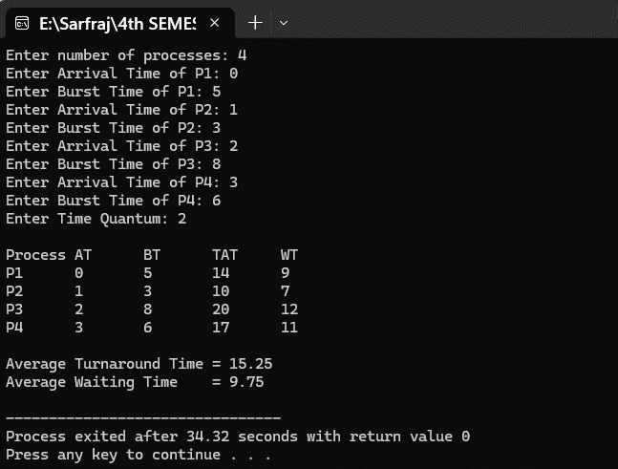


Lab no: 7 Date: 2082/05/14

Title:Write a program to display the process allocation for user input free blocks and incoming process using Best fit allocation.

Introduction
The Best Fit Allocation algorithm is a memory management strategy used in operating systems to allocate processes into available memory blocks in the most space-efficient way possible. When a process requests memory, the operating system searches through the list of free blocks and assigns it to the smallest block that is large enough to hold the process. This approach aims to minimize unused space inside the block, reducing internal fragmentation.
Compared to First Fit (which allocates the first suitable block) and Worst Fit (which allocates the largest available block), Best Fit is more selective, as it tries to utilize memory blocks more efficiently by leaving behind the least amount of leftover space.
However, the Best Fit method has some drawbacks:
- It may lead to external fragmentation, since it leaves behind many very small unusable gaps in memory.
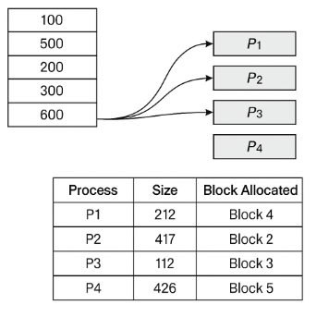
- It requires scanning the entire list of memory blocks to find the “best” match, making it slower than First Fit in practice.

IDE: DEV C++
Source code:

#include <stdio.h>
int main() {
int nb, np;
int blockSize[20], initialBlockSize[20], processSize[20], allocation[20], freeSpace[20];

// Input number of blocks
printf("Enter number of free blocks: ");
scanf("%d", &nb);

printf("Enter size of each block:\n");
for (int i = 0; i < nb; i++) {
printf("Block %d size: ", i + 1);
scanf("%d", &blockSize[i]);
initialBlockSize[i] = blockSize[i]; // Save original size for later
freeSpace[i] = blockSize[i]; // Initially all space is free
}

// Input number of processes
printf("\nEnter number of processes: ");
scanf("%d", &np);

printf("Enter size of each process:\n");
for (int i = 0; i < np; i++) {
printf("Process %d size: ", i + 1);
scanf("%d", &processSize[i]);
allocation[i] = -1; // Initially not allocated
}

// Best Fit Allocation
for (int i = 0; i < np; i++) {
int bestIndex = -1;
for (int j = 0; j < nb; j++) {
if (freeSpace[j] >= processSize[i]) {
if (bestIndex == -1 || freeSpace[j] < freeSpace[bestIndex]) {
bestIndex = j;
}
}
}

if (bestIndex != -1) {
allocation[i] = bestIndex;
freeSpace[bestIndex] -= processSize[i];
}
}

// Process Allocation Table
printf("\nProcess No.\tProcess Size\tBlock No.\tFree Space Remaining\n");
for (int i = 0; i < np; i++) {
printf("%d\t\t%d\t\t", i + 1, processSize[i]);
if (allocation[i] != -1) {
printf("%d\t\t%d", allocation[i] + 1, freeSpace[allocation[i]]);
} else {
printf("Not Allocated\t-");
}
printf("\n");
}

// Final Block Status Table
printf("\nFinal Block Status:\n");
printf("Block No.\tInitial Size\tFinal Free Space\n");
for (int i = 0; i < nb; i++) {
printf("%d\t\t%d\t\t%d\n", i + 1, initialBlockSize[i], freeSpace[i]);
}

return 0;
}

Output:
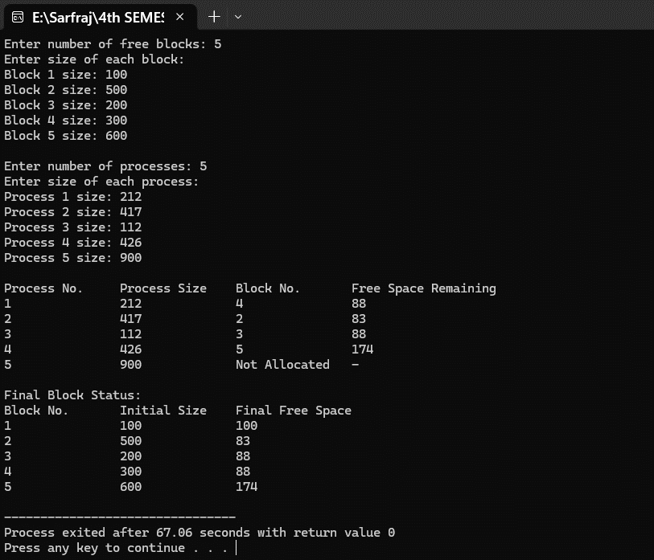

Lab no: 8 Date: 2082/05/14

Title:Write a program to display the process allocation for user input free blocks and incoming process using Worst fit allocation.

Introduction
The Worst Fit Allocation algorithm is a memory management strategy used in operating systems to allocate processes into available memory blocks. Unlike Best Fit, where the process is assigned to the smallest suitable block, in Worst Fit the process is allocated to the largest available free block that can accommodate it. The idea behind this method is to leave behind the largest possible remaining free space, thereby reducing the chances of creating very small unusable fragments.
Compared to First Fit (which allocates the first suitable block) and Best Fit (which allocates the smallest suitable block), Worst Fit tends to spread processes more evenly across memory and avoids filling small blocks quickly. This can sometimes reduce the occurrence of small leftover gaps that cannot be used later.
However, the Worst Fit method also has drawbacks:
- It may lead to poor utilization of memory, since large blocks get split frequently, leaving fragmented free spaces.
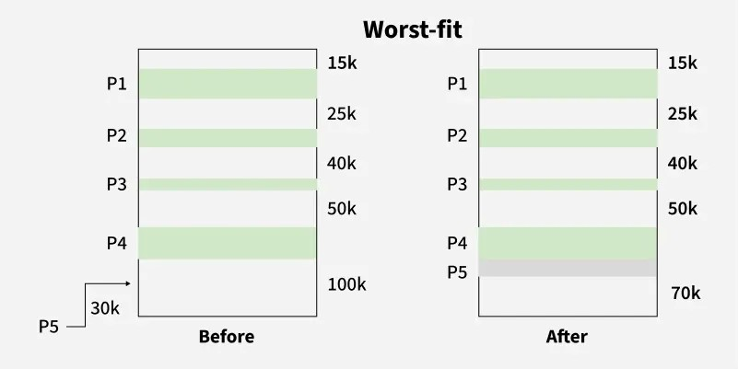
- Like Best Fit, it requires scanning the entire list of free blocks to find the “worst” match, which increases allocation time.

IDE: DEV C++
Source code:

#include <stdio.h>

int main() {
int nb, np,i,j;
int blockSize[20], initialBlockSize[20], processSize[20], allocation[20], freeSpace[20], usedSpaceAfterAlloc[20];

// Input number of blocks
printf("Enter number of free blocks: ");
scanf("%d", &nb);

printf("Enter size of each block:\n");
for ( i = 0; i < nb; i++) {
printf("Block %d size: ", i + 1);
scanf("%d", &blockSize[i]);
initialBlockSize[i] = blockSize[i]; // Store initial size
freeSpace[i] = blockSize[i]; // Initially all space is free
}

// Input number of processes
printf("\nEnter number of processes: ");
scanf("%d", &np);

printf("Enter size of each process:\n");
for (i = 0; i < np; i++) {
printf("Process %d size: ", i + 1);
scanf("%d", &processSize[i]);
allocation[i] = -1; // Not allocated initially
usedSpaceAfterAlloc[i] = -1; // Default for not allocated
}

// Worst Fit Allocation
for (i = 0; i < np; i++) {
int worstIndex = -1;
for (j = 0; j < nb; j++) {
if (freeSpace[j] >= processSize[i]) {
if (worstIndex == -1 || freeSpace[j] > freeSpace[worstIndex]) {
worstIndex = j;
}
}
}

if (worstIndex != -1) {
allocation[i] = worstIndex;
freeSpace[worstIndex] -= processSize[i]; // Update free space
usedSpaceAfterAlloc[i] = freeSpace[worstIndex]; // Record remaining space at this moment
}
}

// Process Allocation Table
printf("\nProcess No.\tProcess Size\tBlock No.\tFree Space Remaining After Allocation\n");
for ( i = 0; i < np; i++) {
printf("%d\t\t%d\t\t", i + 1, processSize[i]);
if (allocation[i] != -1) {
printf("%d\t\t%d", allocation[i] + 1, usedSpaceAfterAlloc[i]);
} else {
printf("Not Allocated\t-");
}
printf("\n");
}

// Final Block Status Table
printf("\nFinal Block Status:\n");
printf("Block No.\tInitial Size\tFinal Free Space\n");
for (i = 0; i < nb; i++) {
printf("%d\t\t%d\t\t%d\n", i + 1, initialBlockSize[i], freeSpace[i]);
}

return 0;
}

Output:
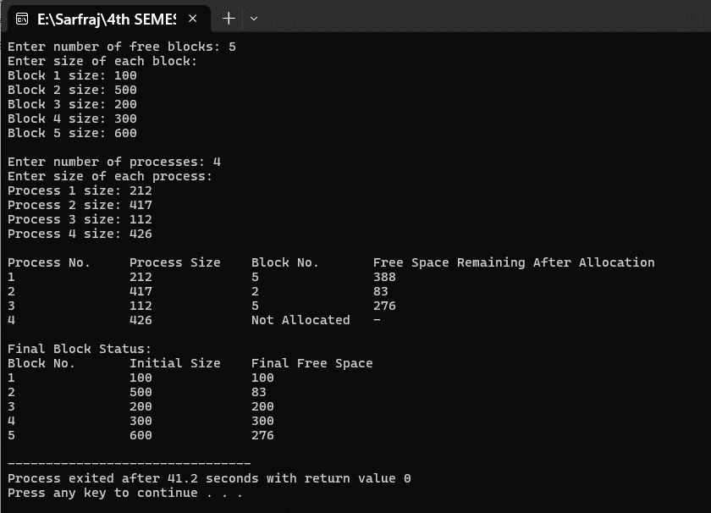

Lab no: 9 Date: 2082/05/14

Title:Write a program to display the process allocation for user input free blocks and incoming process using First fit allocation.

Introduction
The First Fit Allocation algorithm is a memory management strategy used in operating systems to allocate processes into available memory blocks. In this method, the operating system scans the list of free blocks sequentially and assigns the process to the first free block that is large enough to hold it. This makes First Fit one of the simplest and fastest allocation techniques.
Compared to Best Fit (which assigns the smallest suitable block) and Worst Fit (which assigns the largest suitable block), First Fit does not aim for optimal space utilization but instead prioritizes speed, since it stops searching as soon as a suitable block is found. This often results in faster allocation compared to the other methods.
However, the First Fit method also has drawbacks:
- It can lead to external fragmentation, as small gaps may be left unutilized between allocated blocks.
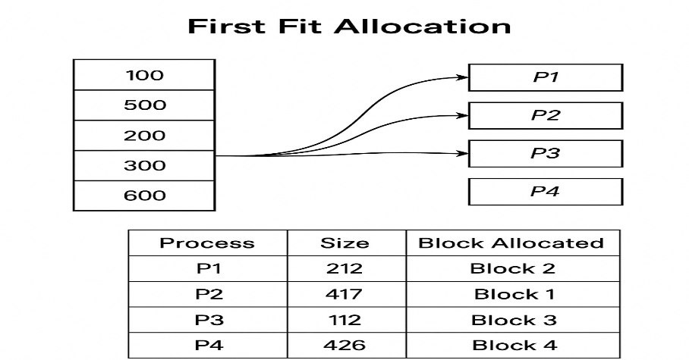
- Over time, the lower part of memory tends to fill up quickly, and larger processes may have to wait even though sufficient free memory exists in higher blocks.

IDE: DEV C++
Source code:

#include <stdio.h>

int main() {
int nb, np;

// Step 1: Input number of free memory blocks
printf("Enter number of free blocks: ");
scanf("%d", &nb);

// Arrays to store block information
int blockSize[nb], blockFree[nb], initialBlockSize[nb];

// Step 2: Input size of each memory block
printf("Enter size of each block:\n");
for (int i = 0; i < nb; i++) {
printf("Block %d size: ", i + 1);
scanf("%d", &blockSize[i]);

blockFree[i] = blockSize[i]; // Initially, all space is free
initialBlockSize[i] = blockSize[i]; // Keep original size for final report
}

// Step 3: Input number of processes
printf("\nEnter number of processes: ");
scanf("%d", &np);

int processSize[np], allocation[np];

// Step 4: Input process sizes
for (int i = 0; i < np; i++) {
printf("Process %d size: ", i + 1);
scanf("%d", &processSize[i]);
allocation[i] = -1; // Initially, no process is allocated
}

// Step 5: First Fit Allocation Algorithm
for (int i = 0; i < np; i++) { // For each process
for (int j = 0; j < nb; j++) { // Find first block that fits
if (blockFree[j] >= processSize[i]) {
allocation[i] = j; // Allocate block j to process i
blockFree[j] -= processSize[i]; // Reduce free space in the block
break; // Stop searching once allocated (First Fit)
}
}
}

// Step 6: Display Process Allocation Table
printf("\nProcess No.\tProcess Size\tBlock No.\tFree Space Remaining After Allocation\n");
for (int i = 0; i < np; i++) {
printf("%d\t\t%d\t\t", i + 1, processSize[i]);
if (allocation[i] != -1)
printf("%d\t\t%d", allocation[i] + 1, blockFree[allocation[i]]);
else
printf("Not Allocated\t-");
printf("\n");
}

// Step 7: Display Final Block Status
printf("\nFinal Block Status:\n");
printf("Block No.\tInitial Size\tFinal Free Space\n");
for (int i = 0; i < nb; i++) {
printf("%d\t\t%d\t\t%d\n", i + 1, initialBlockSize[i], blockFree[i]);
}

return 0;
}

Output:
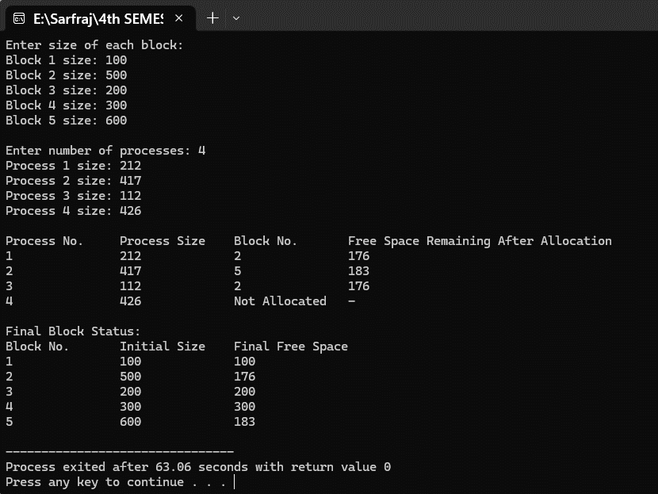

Lab no: 10 Date: 2082/07/12

Title:Write a program to calculate the seek time for user input pending request, total number of cylinder and current position of I/O read/write head using FCFS disk scheduling algorithm.

Introduction
The First-Come-First-Served (FCFS) disk scheduling algorithm is the simplest disk scheduling technique that processes disk I/O requests in the order they arrive in the request queue. In this algorithm, the disk arm moves to satisfy each request in the sequence they were received, without any optimization for minimizing seek time.
How FCFS Works:
- Requests are processed in the order they arrive (First-In-First-Out)
- The disk head moves from its current position to the first request in the queue
- After servicing the first request, it moves to the second request, and so on
- The process continues until all requests are satisfied
- Total seek time is calculated as the sum of distances moved between consecutive requests
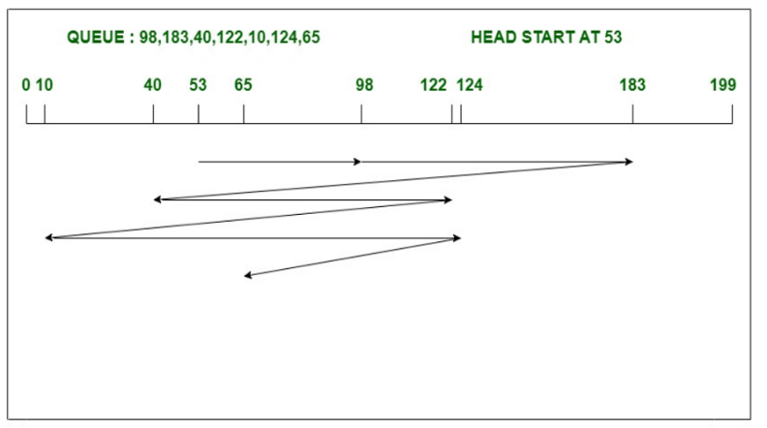

IDE: DEV C++
Language: C
Source code:
#include <stdio.h>
#include <stdlib.h>

int main() {
int n, head, totalCylinders;
int seekTime = 0;

printf("FCFS Disk Scheduling Algorithm by Sarfraj Alam\n");

// Input total cylinders
printf("Enter total number of cylinders: ");
scanf("%d", &totalCylinders);

// Input head position
printf("Enter current position of R/W head: ");
scanf("%d", &head);

// Input request queue size
printf("Enter number of pending requests: ");
scanf("%d", &n);

int requests[n];
printf("Enter the request queue (cylinder numbers):\n");
for (int i = 0; i < n; i++) {
scanf("%d", &requests[i]);
if (requests[i] < 0 || requests[i] >= totalCylinders) {
printf("Invalid request: %d (out of range)\n", requests[i]);
return 1;
}
}

// FCFS scheduling
int current = head;
printf("\nHead Movement Order:\n");
printf("%d", current);
for (int i = 0; i < n; i++) {
seekTime += abs(current - requests[i]);
current = requests[i];
printf(" -> %d", current);
}

// Gantt-style diagram
printf("\n\nDiagrammatic Representation:\n");
printf("----------------------------------------------------\n");
current = head;
printf("| %d ", current);
for (int i = 0; i < n; i++) {
printf("| %d ", requests[i]);
}
printf("|\n");
printf("----------------------------------------------------\n");

// Distances (seek)
printf(" ");
current = head;
for (int i = 0; i < n; i++) {
int dist = abs(current - requests[i]);
printf(" %d ", dist);
current = requests[i];
}
printf("\n");

// Results
printf("\nTotal Seek Time = %d no of cylinders\n", seekTime);
printf("Average Seek Time = %.2f no of cylinders\n", (float)seekTime / n);

return 0;
}

Output:
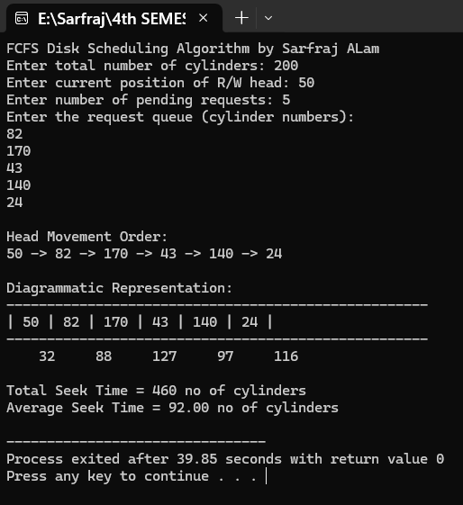

Lab no: 11 Date: 2082/07/12

Title:Write a program to calculate the seek time for user input pending request, total number of cylinder and current position of I/O read/write head using SCAN disk scheduling algorithm.

Introduction
The SCAN disk scheduling algorithm, also called the “Elevator Algorithm”, is one of the most commonly used disk scheduling techniques. The algorithm moves the read/write head in one fixed direction (either left or right), servicing all pending requests on its path. Once it reaches the end of the disk, the head reverses direction and continues servicing requests in the opposite direction, similar to how an elevator moves up and down in a building.
.How SCAN Works:
- The disk arm begins moving in one direction (either toward cylinder 0 or toward the last cylinder).
- All pending requests in that direction are serviced as the head moves.
- When the head reaches the last cylinder in the current direction, it reverses direction.
- The disk arm then services all remaining requests while moving back in the opposite direction.
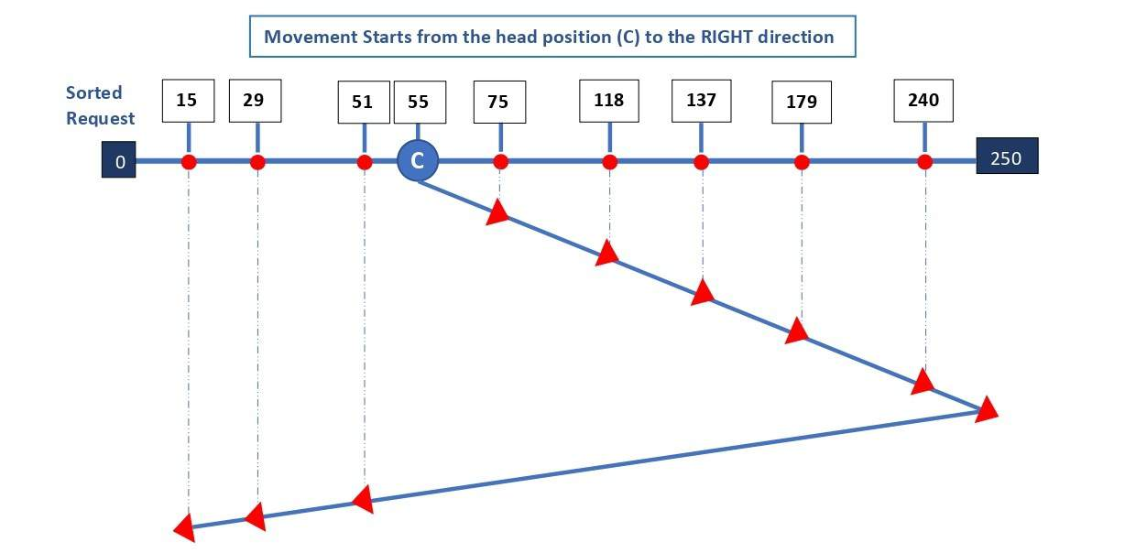
- This process continues until all requests in the queue are processed.

IDE: DEV C++
Language: C
Source code:
#include <stdio.h>
#include <stdlib.h>

int main() {
int totalCylinders, head, n, direction;
int seekTime = 0;

printf("SCAN Disk Scheduling Algorithm by Sarfraj Alam\n");

// Input total cylinders
printf("Enter total number of cylinders: ");
scanf("%d", &totalCylinders);

// Input head position
printf("Enter current position of R/W head: ");
scanf("%d", &head);

// Input size of request queue
printf("Enter number of pending requests: ");
scanf("%d", &n);

int requests[n];
printf("Enter the request queue:\n");
for (int i = 0; i < n; i++) {
scanf("%d", &requests[i]);
if (requests[i] < 0 || requests[i] >= totalCylinders) {
printf("Invalid request %d (out of range)\n", requests[i]);
return 1;
}
}

// Input scan direction
printf("Enter direction (0 = left, 1 = right): ");
scanf("%d", &direction);

// Add head into list for easier processing
int allRequests[n + 1];
for (int i = 0; i < n; i++) {
allRequests[i] = requests[i];
}
allRequests[n] = head;

// Sort all requests (including head)
for (int i = 0; i < n + 1; i++) {
for (int j = i + 1; j < n + 1; j++) {
if (allRequests[i] > allRequests[j]) {
int temp = allRequests[i];
allRequests[i] = allRequests[j];
allRequests[j] = temp;
}
}
}

// Find head index in sorted array
int headIndex = 0;
for (int i = 0; i < n + 1; i++) {
if (allRequests[i] == head) {
headIndex = i;
break;
}
}

printf("\nHead Movement Order:\n%d", head);

// SCAN to the right
if (direction == 1) {
// Move from head to right end
for (int i = headIndex + 1; i < n + 1; i++) {
seekTime += abs(head - allRequests[i]);
head = allRequests[i];
printf(" -> %d", head);
}

// Go to last cylinder
if (head != totalCylinders - 1) {
seekTime += abs(head - (totalCylinders - 1));
head = totalCylinders - 1;
printf(" -> %d", head);
}

// Then move left servicing remaining requests
for (int i = headIndex - 1; i >= 0; i--) {
seekTime += abs(head - allRequests[i]);
head = allRequests[i];
printf(" -> %d", head);
}
}

// SCAN to the left
else {
// Move from head left
for (int i = headIndex - 1; i >= 0; i--) {
seekTime += abs(head - allRequests[i]);
head = allRequests[i];
printf(" -> %d", head);
}

// Go to cylinder 0
if (head != 0) {
seekTime += abs(head - 0);
head = 0;
printf(" -> %d", head);
}

// Then move right servicing remaining requests
for (int i = headIndex + 1; i < n + 1; i++) {
seekTime += abs(head - allRequests[i]);
head = allRequests[i];
printf(" -> %d", head);
}
}

printf("\n\nTotal Seek Time = %d cylinders\n", seekTime);
printf("Average Seek Time = %.2f cylinders\n", (float)seekTime / n);

return 0;
}

Outputs:
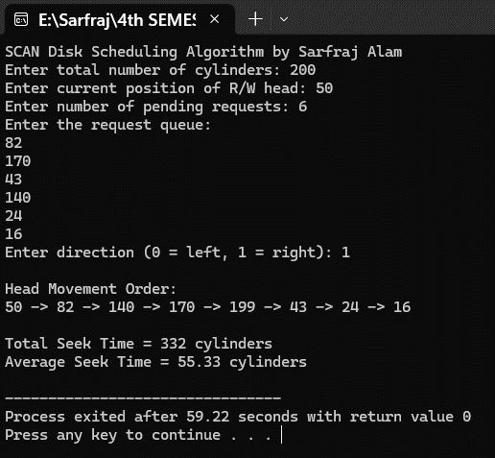

Lab no: 12 Date: 2082/07/12

Title:Write a program to calculate the seek time for user input pending request, total number of cylinder and current position of I/O read/write head using LOOK disk scheduling algorithm.

Introduction
The LOOK disk scheduling algorithm is an efficient disk scheduling technique that improves on SCAN. Unlike SCAN, which always moves the head to the ends of the disk, LOOK only moves the head as far as the farthest request in the current direction. Once it reaches the farthest request, the head reverses direction and continues servicing remaining requests, similar to an elevator that only moves as far as the top or bottom passenger. This reduces unnecessary movement and decreases overall seek time.

How LOOK Works:
- The disk arm begins moving in a chosen direction (left or right).
- All pending requests in that direction are serviced as the head moves.
- When the head reaches the farthest request in the current direction, it reverses direction.
- The disk arm then services all remaining requests while moving in the opposite direction.
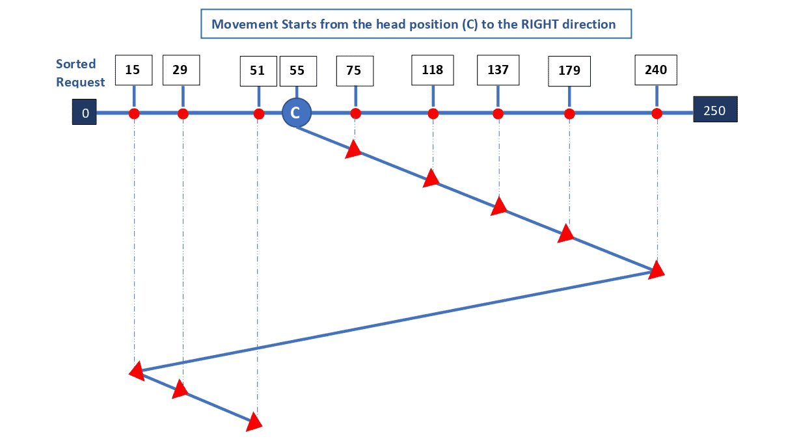
- This process continues until all requests are serviced.

IDE: DEV C++
Language: C
Source code:
#include <stdio.h>
#include <stdlib.h>

int main() {
int totalCylinders, head, n, direction;
int seekTime = 0;

printf("LOOK Disk Scheduling Algorithm by Sarfraj Alam\n");

// Input total cylinders
printf("Enter total number of cylinders: ");
scanf("%d", &totalCylinders);

// Input head position
printf("Enter current position of R/W head: ");
scanf("%d", &head);

// Input size of request queue
printf("Enter number of pending requests: ");
scanf("%d", &n);

int requests[n];
printf("Enter the request queue:\n");
for (int i = 0; i < n; i++) {
scanf("%d", &requests[i]);
if (requests[i] < 0 || requests[i] >= totalCylinders) {
printf("Invalid request %d (out of range)\n", requests[i]);
return 1;
}
}

// Input LOOK direction
printf("Enter direction (0 = left, 1 = right): ");
scanf("%d", &direction);

// Sort the request queue
for (int i = 0; i < n; i++) {
for (int j = i + 1; j < n; j++) {
if (requests[i] > requests[j]) {
int temp = requests[i];
requests[i] = requests[j];
requests[j] = temp;
}
}
}

printf("\nHead Movement Order:\n%d", head);

// LOOK to the right first
if (direction == 1) {
// Move from head to the farthest right request
for (int i = 0; i < n; i++) {
if (requests[i] >= head) {
seekTime += abs(head - requests[i]);
head = requests[i];
printf(" -> %d", head);
}
}
// Then move left to remaining requests
for (int i = n - 1; i >= 0; i--) {
if (requests[i] < head) {
seekTime += abs(head - requests[i]);
head = requests[i];
printf(" -> %d", head);
}
}
}

// LOOK to the left first
else {
// Move from head to the farthest left request
for (int i = n - 1; i >= 0; i--) {
if (requests[i] <= head) {
seekTime += abs(head - requests[i]);
head = requests[i];
printf(" -> %d", head);
}
}
// Then move right to remaining requests
for (int i = 0; i < n; i++) {
if (requests[i] > head) {
seekTime += abs(head - requests[i]);
head = requests[i];
printf(" -> %d", head);
}
}
}

printf("\n\nTotal Seek Time = %d cylinders\n", seekTime);
printf("Average Seek Time = %.2f cylinders\n", (float)seekTime / n);

return 0;
}

Outputs:
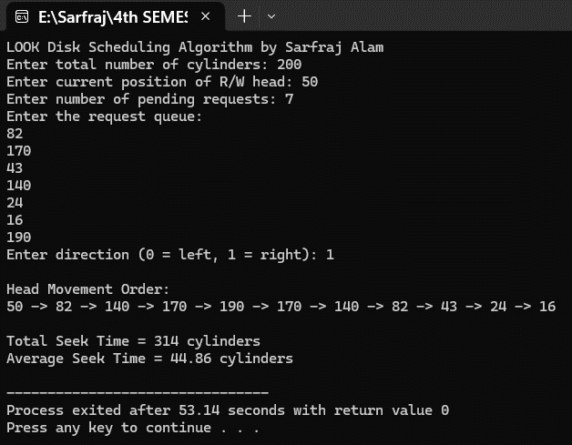

Lab no: 13 Date: 2082/07/12

Title:Write a program to test if the system is free from deadlock or not for the user input allocation, max and available matrix.

Introduction
The Banker’s Algorithm is a resource allocation and deadlock avoidance algorithm used in operating systems. It ensures that a system can allocate resources to processes safely without leading to deadlock. The algorithm works like a bank that only lends money if it can guarantee that all clients can eventually be served.

Key Terms
- Available: The number of available instances of each resource type.
- Max: The maximum demand of each process for each resource type.
- Allocation: The number of resources currently allocated to each process.
- Need: The remaining resources a process may still request to complete its task.
Need = Max − Allocation

How Banker's Algorithm Works
- When a process requests resources, the system checks if the request can be safely granted.
- The system pretends to allocate the requested resources.
- It then checks if there is a safe sequence of process execution:
- A sequence in which all processes can finish without waiting indefinitely.
- If a safe sequence exists, the request is granted; otherwise, the process must wait.
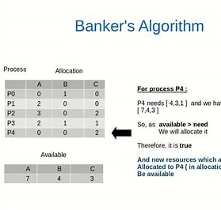

IDE: DEV C++
Language: C
Sourse code:
#include <stdio.h>

int main() {
int n, m; // n = number of processes, m = number of resources

printf("Enter number of processes: ");
scanf("%d", &n);

printf("Enter number of resources: ");
scanf("%d", &m);

int allocation[n][m];
int max[n][m];
int available[m];
int need[n][m];

// Input Allocation Matrix
printf("\nEnter Allocation Matrix:\n");
for (int i = 0; i < n; i++) {
printf("Process %d: ", i);
for (int j = 0; j < m; j++)
scanf("%d", &allocation[i][j]);
}

// Input Max Matrix
printf("\nEnter Maximum Matrix:\n");
for (int i = 0; i < n; i++) {
printf("Process %d: ", i);
for (int j = 0; j < m; j++)
scanf("%d", &max[i][j]);
}

// Input Available Matrix
printf("\nEnter Available Resources: ");
for (int j = 0; j < m; j++)
scanf("%d", &available[j]);

// Calculate Need Matrix = Max - Allocation
for (int i = 0; i < n; i++)
for (int j = 0; j < m; j++)
need[i][j] = max[i][j] - allocation[i][j];

int finish[n];
for (int i = 0; i < n; i++)
finish[i] = 0; // initialize all processes as unfinished

int safeSeq[n];
int count = 0;

// Banker's Algorithm
while (count < n) {
int found = 0;

for (int p = 0; p < n; p++) {
if (!finish[p]) {
int canAllocate = 1;
for (int r = 0; r < m; r++) {
if (need[p][r] > available[r]) {
canAllocate = 0;
break;
}
}

if (canAllocate) {
// Allocate resources
for (int r = 0; r < m; r++)
available[r] += allocation[p][r];

safeSeq[count++] = p;
finish[p] = 1;
found = 1;
}
}
}

if (!found) {
printf("\nSystem is NOT SAFE! Deadlock may occur.\n");
return 0;
}
}

// Print safe sequence
printf("\nSystem is SAFE.\nSafe Sequence is: ");
for (int i = 0; i < n; i++) {
printf("P%d", safeSeq[i]);
if (i != n - 1) printf(" -> ");
}
printf("\n");

return 0;
}
Output:

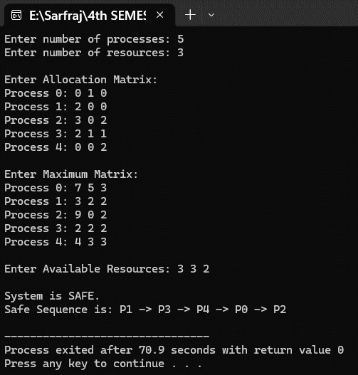

Lab no: 14 Date: 2082/08/15

Title:Prepare a lab report for basic Linux command.

Introduction
Linux is a powerful operating system that provides a command-line interface (CLI) for efficient system administration and file management. Basic Linux commands are essential tools that allow users to navigate the file system, manage files and directories, monitor system processes, and perform various administrative tasks. Understanding these fundamental commands is crucial for working effectively in a Linux environment.
Command Line Interface (CLI): The CLI provides direct access to the operating system through text-based commands. It offers more precision and power compared to graphical interfaces, making it preferred by system administrators and developers.
Basic Command Structure:
command [options] [arguments]

Terminal: Kali Linux Terminal

Operating System: Kali Linux

Some Basic Commands in Kali Linux

1. pwd (Print Working Directory)
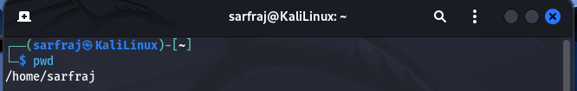
Purpose: Displays the current directory path

2. cd (Change Directory)
Purpose: Navigate between directories
cd /path/to/directory# Change to specific directory
cd .. # Move to parent directory
cd ~ # Move to home directory
cd - # Move to previous directory

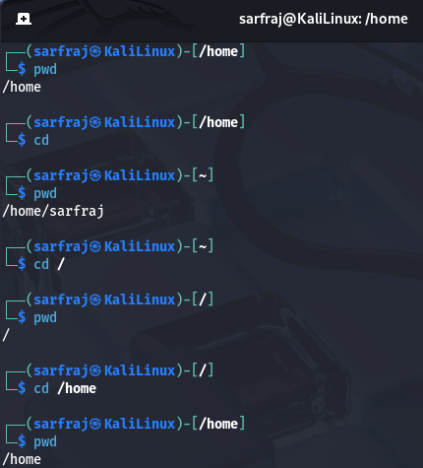

3. ls (List Directory Contents)
Purpose: Display files and directories
ls # List current directory
ls -l # Long format listing
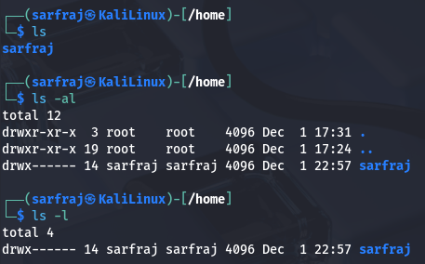
ls -al # Include hidden files

4. nano (Text Editor)
Purpose: Simple command-line text editor
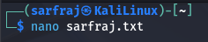

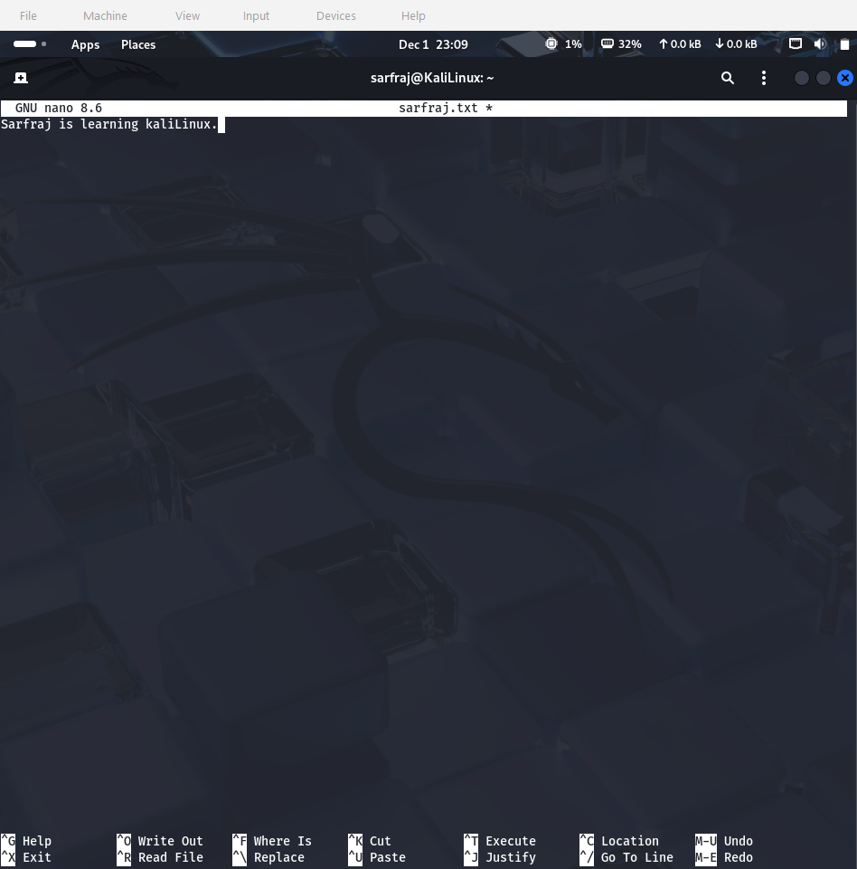

5. cat (Concatenate and Display)
Purpose: Display file contents or combine files
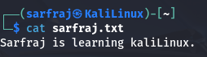

6.Mkdir (Make Directory)
Purpose: Create new directories
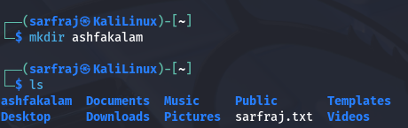

7. shred (Secure File Deletion)
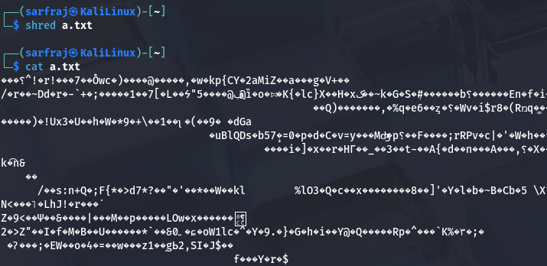
Purpose: Securely delete files by overwriting data

8. cp (Copy Files/Directories)
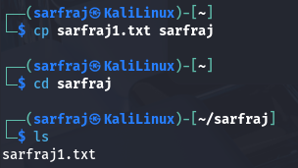
Purpose: Copy files and directories

9. rm (Remove Files/Directories)
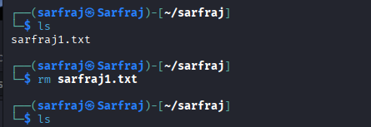
Purpose: Delete files and directories

10. echo (Display Text)
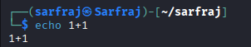
Purpose: Display text or create simple files

11. cal (Calendar)
Purpose: Display calendar
Syntax: cal [OPTION] [MONTH] [YEAR]
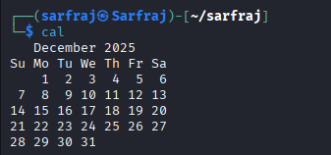

12. time (Command Execution Time)
Purpose: Measure command execution time
Syntax: time [OPTION] COMMAND
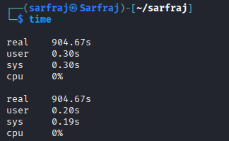

13. ifconfig (Network Interface Configuration)
Purpose: Configure and display network interfaces
Syntax: ifconfig [INTERFACE] [OPTIONS]
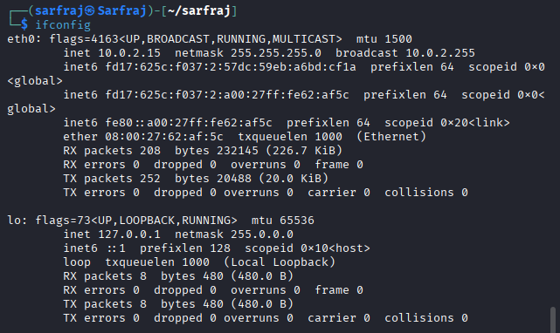

14. ip address (Modern Network Configuration)
Purpose: Modern replacement for ifconfig
Syntax: ip [OPTIONS] OBJECT COMMAND
Options:
- addr : Address management
- link : Network device management
- route : Routing table management
- -4 : IPv4 only
- -6 : IPv6 only
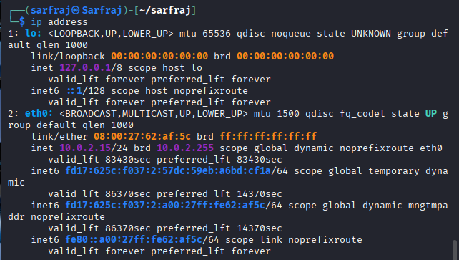

15. cmp (Compare Files)
Purpose: Compare two files byte by byte
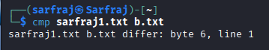

16. sort (Sort File Contents)
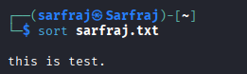
Purpose: Sort lines in text files

17. ping (Network Connectivity Test)
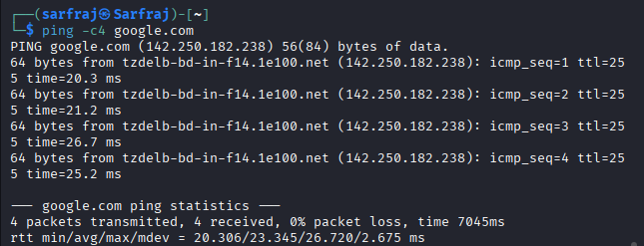
Purpose: Test network connectivity to remote hosts

18. traceroute (Network Route Tracing)
Purpose: Trace network route to destination

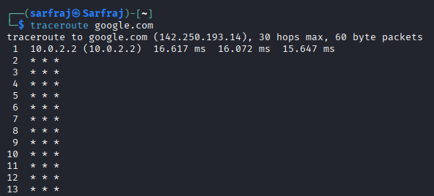

19. sudo(superuserdo) and apt (System Administration)
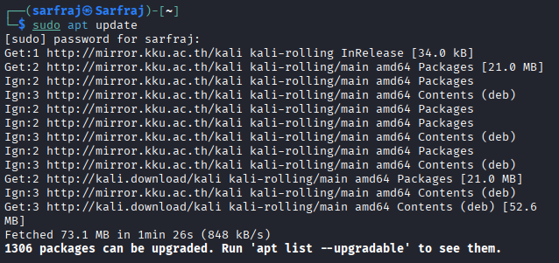
Purpose: Execute commands as root and manage packages

20. grep (Text Search)
Purpose: Search for patterns in files

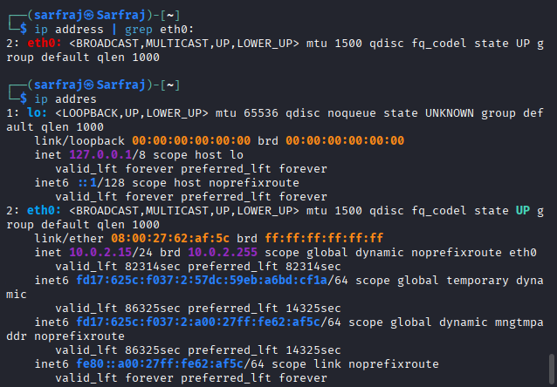

Conclusion:
These 20 basic Linux commands form the foundation of command-line operations in Kali Linux. They cover:
- File Management: pwd, cd, ls, mkdir, cp, rm
- Text Operations: nano, cat, echo, grep, sort, cmp
- System Information: cal, time, ifconfig, ip address
- Network Operations: ping, traceroute
- Security: shred
- System Administration: sudo, apt

Lab no: 15 Date: 2082/08/15
Title:Prepare a lab report to create and terminate process.

Introduction
Process management is a fundamental concept in operating systems. A process is a running instance of a program that contains the program code and its current activity. Understanding how to create and terminate processes is crucial for system administration, programming, and managing system resources effectively.
Process Concepts:
- Process: An executing program with its own memory space
- Process ID (PID): Unique identifier assigned to each process
- Parent Process: Process that creates another process
- Child Process: Process created by another process
- Process State: Current status of a process (running, sleeping, stopped, zombie)
Process Termination Methods:
- Natural Termination: Process completes execution
- Signal Termination: Using kill signals
- Force Termination: Forceful process killing
- Parent Termination: When parent process ends

Terminal: Kali Linux Terminal

Operating System: Kali Linux

Source code:

- Process creation
sleep 300 & # Create a sleep process for 300 seconds
[1] 54204 # Process id
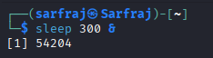

- Viewing Processes
ps aux | grep sleep # Find specific process
sarfraj 54204 0.0 0.0 5580 1996 pts/0 SN 05:18 0.00 sleep 300
sarfraj 54327 0.0 0.1 6528 2308 pts/0 S+ 05:18 0.00 grep --color=auto sleep
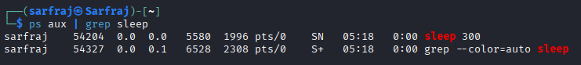

- Terminating the process
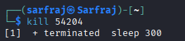
kill 54204 # Stop process by ID number

- Checking if the process is terminated or not

Output:

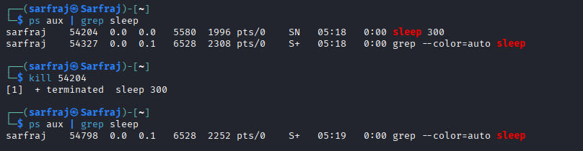

Process Information:
- PID: Process ID number (unique for each process)
- Job: Background job number [1], [2], etc.
- Status: Running, Terminated, Stopped

Conclusion:
Successfully created and terminated processes in Kali Linux:
- Created sleep process with sleep 300 &
- Found process using ps aux | grep sleep
- Terminated process with kill 30410
- Verified termination with ps aux | grep sleep

